APPENDIX B
Water Inflow-Outflow Diagrams and Exceedance Flows
Table of Contents
Page
Middle Fork American Project Water Inflow-Outflow Diagram. 1
Ralston Afterbay 2
Middle Fork Interbay 4
French Meadows Reservoir 6
Hell Hole Reservoir 8
North Fork Long Canyon 10
South Fork Long Canyon 12
Duncan Creek 14

Middle Fork American Project Water Inflow-Outflow Diagram.
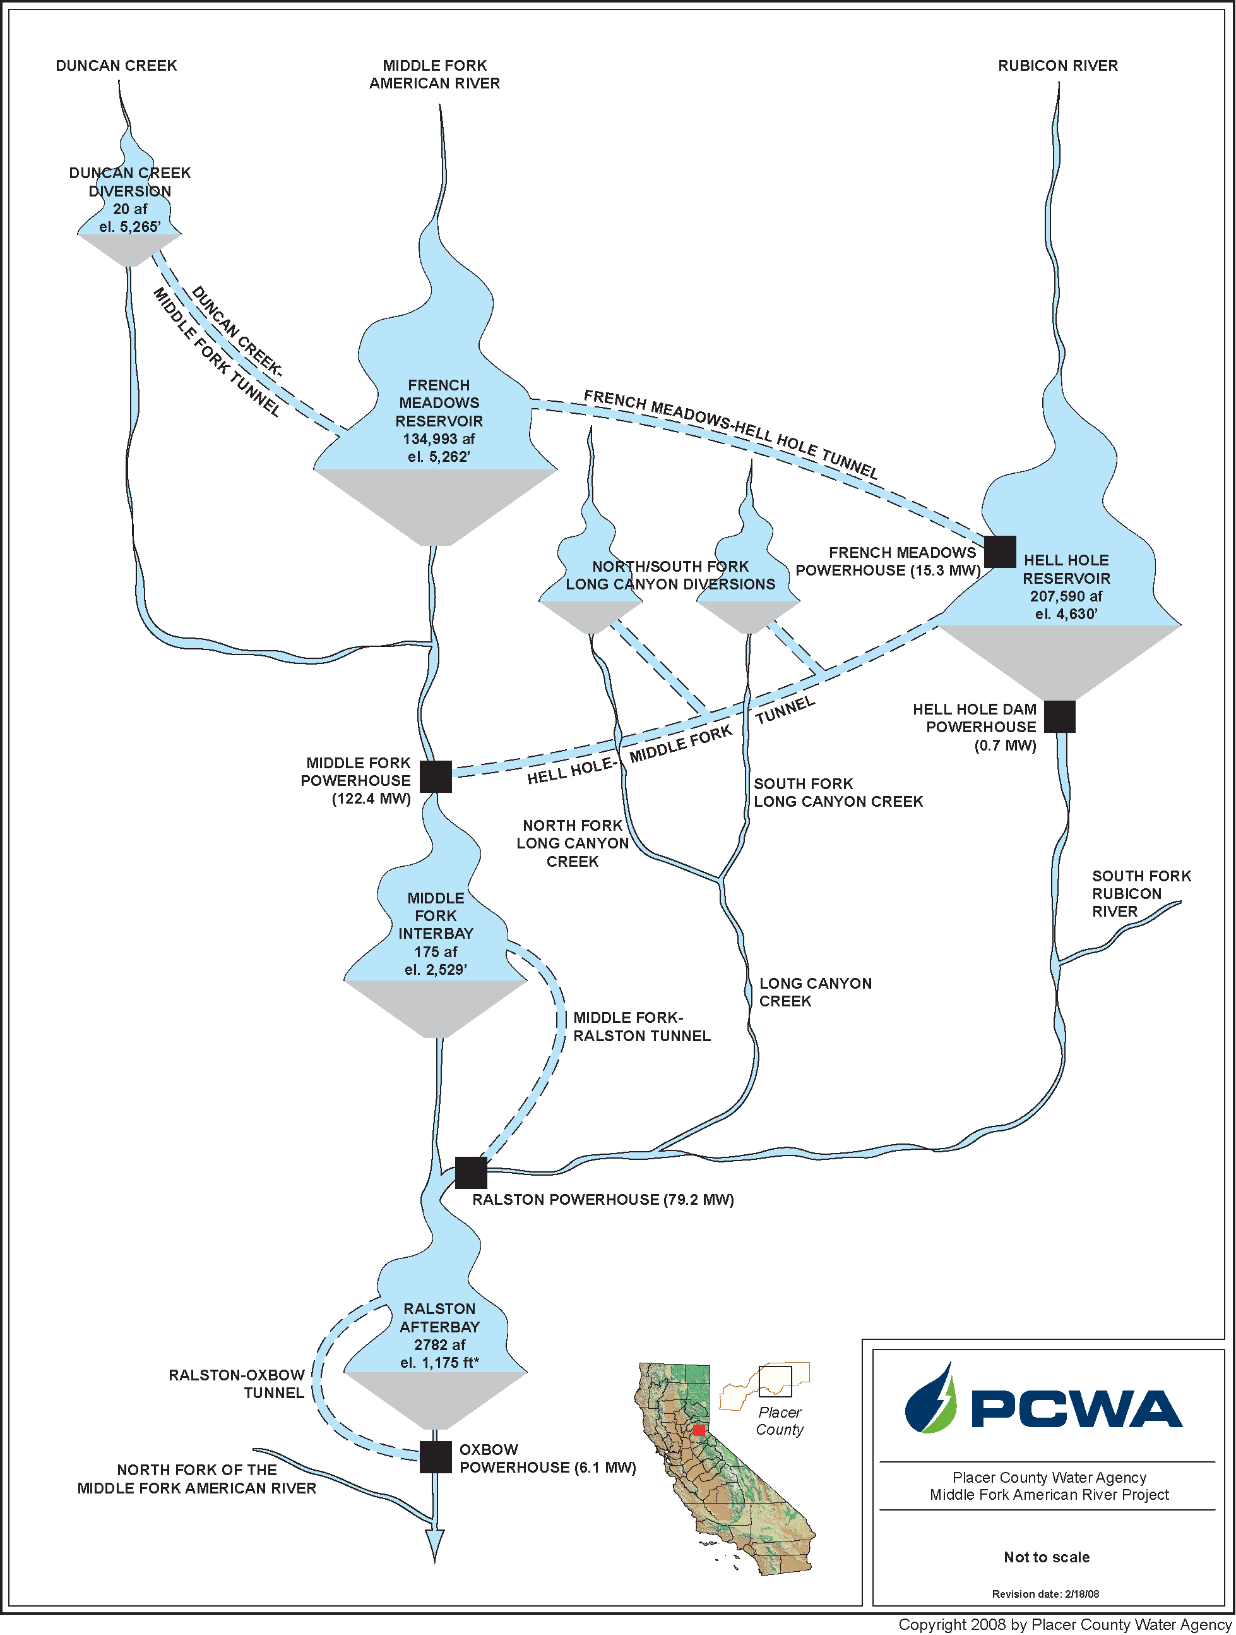

Ralston Afterbay
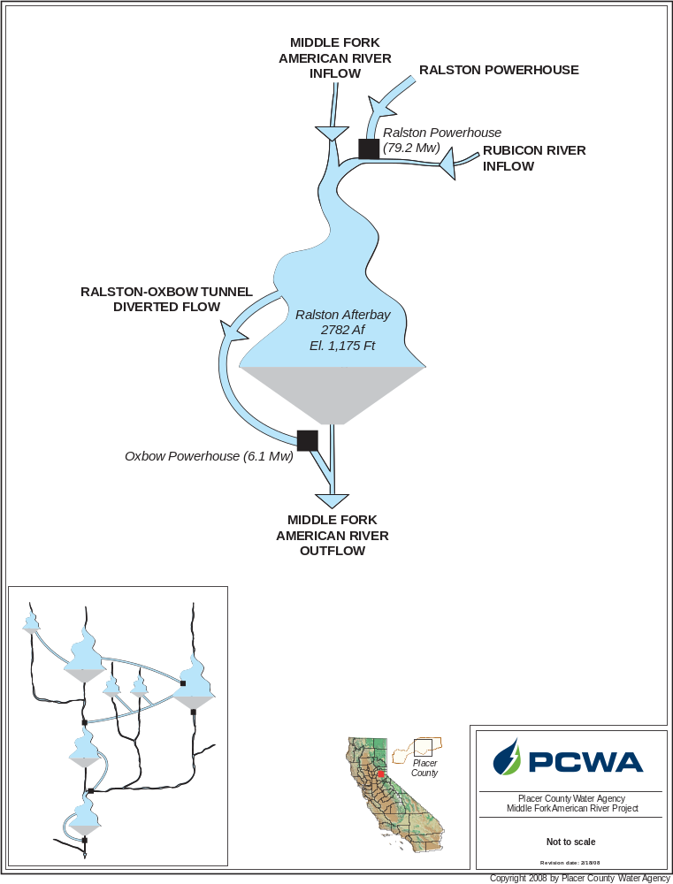
Ralston Afterbay Water Budget.
Month | Exceedances
Month | 10 % | 20% | 50% | 80% | 90%
Rubicon River Inflow
Oct | 83 | 75 | 64 | 41 | 29
Nov | 175 | 100 | 69 | 49 | 44
Dec | 481 | 181 | 84 | 56 | 48
Jan | 1102 | 588 | 159 | 65 | 49
Feb | 1287 | 767 | 274 | 107 | 84
Mar | 1358 | 918 | 424 | 185 | 129
Apr | 1051 | 772 | 389 | 150 | 103
May | 1041 | 630 | 198 | 100 | 82
Jun | 600 | 225 | 126 | 63 | 52
Jul | 151 | 113 | 76 | 44 | 33
Aug | 93 | 78 | 56 | 38 | 26
Sep | 83 | 73 | 52 | 37 | 26
Middle Fork Amercian River Inflow
Oct | 62 | 47 | 31 | 22 | 19
Nov | 101 | 64 | 41 | 30 | 20
Dec | 213 | 104 | 46 | 31 | 21
Jan | 396 | 202 | 60 | 40 | 27
Feb | 578 | 224 | 89 | 46 | 38
Mar | 572 | 277 | 115 | 62 | 43
Apr | 386 | 242 | 108 | 58 | 46
May | 403 | 159 | 62 | 43 | 33
Jun | 304 | 99 | 50 | 36 | 29
Jul | 77 | 55 | 38 | 28 | 21
Aug | 47 | 38 | 32 | 20 | 17
Sep | 45 | 36 | 30 | 20 | 16
Ralston Afterbay
Ralston Afterbay Water Budget (continued).
Month | Exceedances
Month | 10 % | 20% | 50% |  | 80% |  | 90%
Ralston Powerhouse Inflow
Oct | 797 | 602 | 88 |  | 0 |  | 0
Nov | 768 | 602 | 434 |  | 29 |  | 0
Dec | 908 | 679 | 272 |  | 18 |  | 0
Jan | 906 | 637 | 261 |  | 21 |  | 0
Feb | 911 | 891 | 443 |  | 34 |  | 9
Mar | 914 | 909 | 586 |  | 57 |  | 38
Apr | 918 | 911 | 452 |  | 46 |  | 25
May | 915 | 911 | 586 |  | 27 |  | 12
Jun | 914 | 909 | 583 |  | 232 |  | 18
Jul | 908 | 843 | 597 |  | 331 |  | 40
Aug | 909 | 850 | 615 |  | 400 |  | 174
Sep | 868 | 703 | 502 |  | 88 |  | 0
Middle Fork American River Outflow
Oct | 139 | 109 |  | 74 |  | -1 |  | -33
Nov | 178 | 110 |  | 48 |  | -14 |  | -51
Dec | 472 | 170 |  | 58 |  | -9 |  | -53
Jan | 1184 | 597 |  | 86 |  | 19 |  | -28
Feb | 1636 | 860 |  | 132 |  | 33 |  | -19
Mar | 1731 | 1152 |  | 255 |  | 55 |  | -32
Apr | 1269 | 843 |  | 178 |  | 59 |  | 3
May | 1419 | 562 |  | 139 |  | 53 |  | 13
Jun | 950 | 253 |  | 81 |  | -1 |  | -31
Jul | 166 | 114 |  | 34 |  | -18 |  | -40
Aug | 93 | 68 |  | 19 |  | -25 |  | -48
Sep | 102 | 87 |  | 16 |  | -33 |  | -55
Ralston - Oxbow Tunnel Diverted Flow
Oct | 861 | 730 |  | 0 |  | 0 |  | 0
Nov | 910 | 758 |  | 544 |  | 51 |  | 0
Dec | 958 | 877 |  | 459 |  | 77 |  | 17
Jan | 971 | 942 |  | 570 |  | 103 |  | 34
Feb | 978 | 968 |  | 834 |  | 197 |  | 85
Mar | 981 | 969 |  | 907 |  | 309 |  | 196
Apr | 983 | 975 |  | 841 |  | 188 |  | 102
May | 984 | 971 |  | 843 |  | 120 |  | 60
Jun | 976 | 961 |  | 724 |  | 351 |  | 76
Jul | 950 | 914 |  | 708 |  | 428 |  | 69
Aug | 939 | 907 |  | 730 |  | 462 |  | 197
Sep | 914 | 808 |  | 604 |  | 154 |  | 0
Percent Diverted
Oct | 107 | 100 |  | 0 |  | 0 |  | 0
Nov | 108 | 102 |  | 85 |  | 25 |  | 0
Dec | 101 | 93 |  | 74 |  | 29 |  | 6
Jan | 96 | 86 |  | 59 |  | 32 |  | 12
Feb | 90 | 82 |  | 55 |  | 31 |  | 18
Mar | 80 | 71 |  | 47 |  | 31 |  | 23
Apr | 63 | 56 |  | 39 |  | 24 |  | 14
May | 55 | 48 |  | 35 |  | 21 |  | 15
Jun | 98 | 88 |  | 62 |  | 30 |  | 21
Jul | 108 | 102 |  | 92 |  | 68 |  | 26
Aug | 109 | 105 |  | 97 |  | 90 |  | 76
Sep | 111 | 107 |  | 99 |  | 72 |  | 0

Middle Fork Interbay
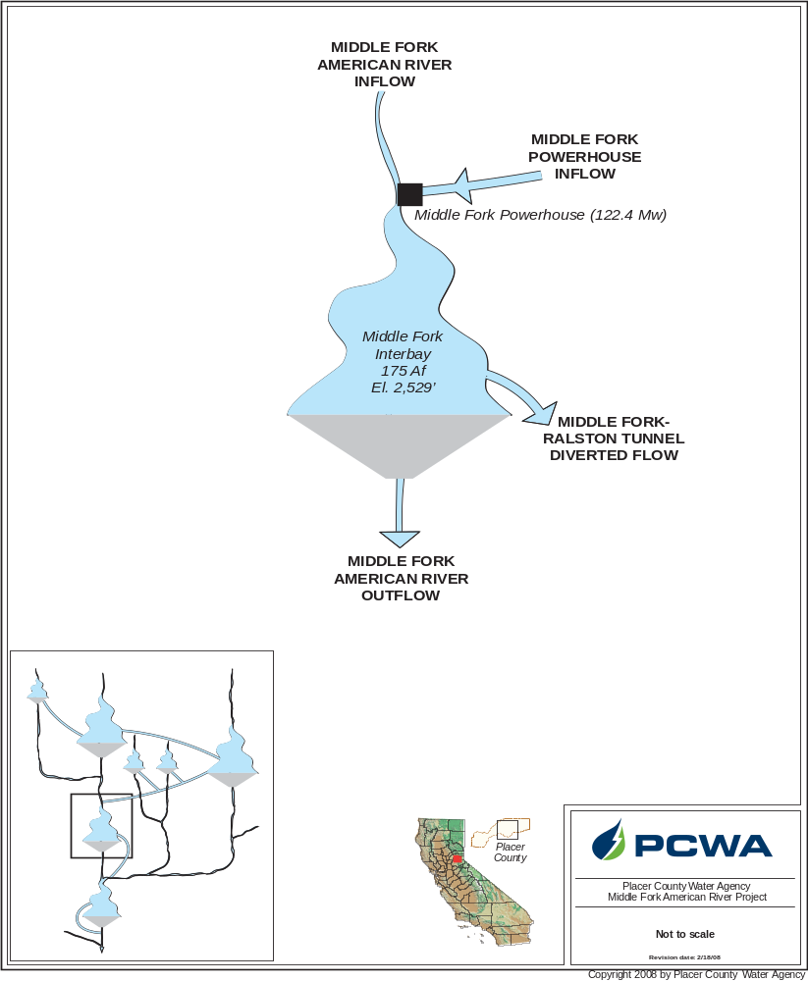
Middle Fork Interbay Water Budget.
Month | Exceedances
Month | 10 % | 20% | 50% | 80% | 90%
Middle Fork American River Inflow
Oct | 27 | 22 | 18 | 14 | 11
Nov | 74 | 42 | 20 | 17 | 15
Dec | 194 | 84 | 34 | 21 | 17
Jan | 309 | 193 | 63 | 24 | 20
Feb | 346 | 222 | 106 | 43 | 28
Mar | 415 | 283 | 148 | 88 | 67
Apr | 301 | 242 | 148 | 77 | 57
May | 411 | 275 | 90 | 46 | 35
Jun | 230 | 88 | 47 | 25 | 19
Jul | 53 | 42 | 27 | 17 | 13
Aug | 29 | 24 | 19 | 13 | 11
Sep | 23 | 20 | 18 | 13 | 10
Middle Fork Powerhouse Inflow
Oct | 806 | 583 | 73 | 0 | 0
Nov | 700 | 584 | 385 | 6 | 0
Dec | 828 | 641 | 242 | 0 | 0
Jan | 795 | 494 | 189 | 0 | 0
Feb | 842 | 768 | 353 | 0 | 0
Mar | 906 | 823 | 410 | 0 | 0
Apr | 933 | 827 | 277 | 0 | 0
May | 935 | 897 | 395 | 0 | 0
Jun | 924 | 886 | 557 | 215 | 0
Jul | 896 | 846 | 570 | 308 | 26
Aug | 912 | 861 | 617 | 368 | 169
Sep | 883 | 711 | 487 | 139 | 0

Middle Fork Interbay
Middle Fork Interbay Water Budget. (continued)
Month | Exceedances
Month | 10 % | 20% | 50% | 80% | 90%
Middle Fork American River Outflow
Oct | 27 | 24 | 19 | 15 | 11
Nov | 30 | 24 | 23 | 18 | 12
Dec | 58 | 26 | 23 | 19 | 12
Jan | 158 | 40 | 24 | 18 | 13
Feb | 198 | 51 | 24 | 20 | 13
Mar | 350 | 115 | 25 | 23 | 19
Apr | 243 | 134 | 24 | 23 | 23
May | 336 | 85 | 24 | 23 | 18
Jun | 232 | 66 | 24 | 21 | 13
Jul | 51 | 24 | 23 | 19 | 13
Aug | 24 | 24 | 22 | 15 | 12
Sep | 25 | 24 | 20 | 13 | 12
Middle Fork - Ralston Tunnel Diverted Flow
Oct | 797 | 602 | 88 | 0 | 0
Nov | 768 | 602 | 434 | 29 | 0
Dec | 908 | 679 | 272 | 18 | 0
Jan | 906 | 637 | 261 | 21 | 0
Feb | 911 | 891 | 443 | 34 | 9
Mar | 914 | 909 | 586 | 57 | 38
Apr | 918 | 911 | 452 | 46 | 25
May | 915 | 911 | 586 | 27 | 12
Jun | 914 | 909 | 583 | 232 | 18
Jul | 908 | 843 | 597 | 331 | 40
Aug | 909 | 850 | 615 | 400 | 174
Sep | 868 | 703 | 502 | 88 | 0
Percent Diverted
Oct | 154 | 105 | 61 | 0 | 0
Nov | 183 | 117 | 96 | 42 | 0
Dec | 178 | 114 | 90 | 37 | 0
Jan | 157 | 110 | 86 | 35 | 0
Feb | 129 | 106 | 89 | 40 | 17
Mar | 112 | 97 | 82 | 50 | 40
Apr | 116 | 99 | 82 | 48 | 37
May | 119 | 101 | 88 | 44 | 28
Jun | 138 | 108 | 93 | 65 | 18
Jul | 140 | 110 | 97 | 80 | 44
Aug | 132 | 109 | 97 | 87 | 67
Sep | 142 | 111 | 96 | 46 | 0

French Meadows Reservoir
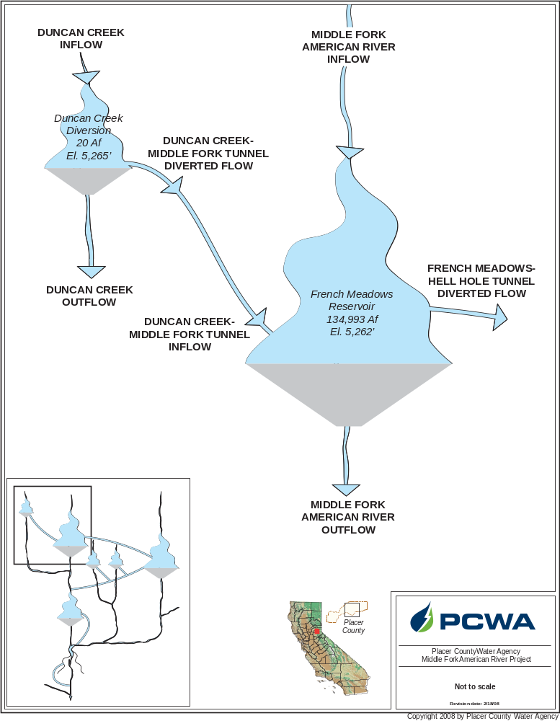

French Meadows Water Budget.
Month | Exceedances
Month | 10 % | 20% | 50% | 80% | 90%
Middle Fork American River Inflow
Oct | 24 | 14 | 6 | 2 | 1
Nov | 119 | 55 | 14 | 5 | 4
Dec | 209 | 84 | 28 | 12 | 9
Jan | 313 | 170 | 52 | 20 | 14
Feb | 323 | 205 | 102 | 30 | 21
Mar | 498 | 310 | 169 | 97 | 67
Apr | 621 | 486 | 283 | 170 | 122
May | 894 | 719 | 396 | 175 | 104
Jun | 774 | 492 | 133 | 42 | 24
Jul | 179 | 89 | 33 | 15 | 10
Aug | 44 | 27 | 13 | 6 | 3
Sep | 23 | 15 | 6 | 3 | 2
Duncan Creek - French Meadows Tunnel Inflow
Oct | 0 | 0 | 0 | 0 | 0
Nov | 20 | 4 | 0 | 0 | 0
Dec | 40 | 11 | 0 | 0 | 0
Jan | 51 | 24 | 2 | 0 | 0
Feb | 50 | 31 | 9 | 0 | 0
Mar | 86 | 55 | 24 | 8 | 3
Apr | 128 | 100 | 52 | 24 | 15
May | 193 | 151 | 80 | 26 | 12
Jun | 157 | 90 | 8 | 0 | 0
Jul | 12 | 1 | 0 | 0 | 0
Aug | 0 | 0 | 0 | 0 | 0
Sep | 0 | 0 | 0 | 0 | 0
French Meadows Reservoir
French Meadows Water Budget (continued).
Month | Exceedances
Month | 10 % |  | 20% |  | 50% |  | 80% |  | 90%
Middle Fork American River Outflow
Oct |  | 10 |  | 10 |  | 9 |  | 7 |  | 5
Nov |  | 12 |  | 10 |  | 9 |  | 7 |  | 6
Dec |  | 14 |  | 11 |  | 10 |  | 7 |  | 6
Jan |  | 17 |  | 13 |  | 10 |  | 9 |  | 6
Feb |  | 16 |  | 13 |  | 10 |  | 8 |  | 6
Mar |  | 18 |  | 15 |  | 11 |  | 9 |  | 8
Apr |  | 16 |  | 14 |  | 11 |  | 9 |  | 8
May |  | 23 |  | 14 |  | 10 |  | 8 |  | 7
Jun |  | 14 |  | 11 |  | 10 |  | 7 |  | 5
Jul |  | 11 |  | 10 |  | 9 |  | 7 |  | 5
Aug |  | 10 |  | 10 |  | 9 |  | 7 |  | 5
Sep |  | 10 |  | 10 |  | 9 |  | 8 |  | 5
French Meadows-Hell Hole Tunnel Diverted Flow
Oct |  | 353 |  | 334 |  | 237 |  | 0 |  | 0
Nov |  | 343 |  | 327 |  | 0 |  | 0 |  | 0
Dec |  | 352 |  | 241 |  | 0 |  | 0 |  | 0
Jan |  | 334 |  | 239 |  | 0 |  | 0 |  | 0
Feb |  | 352 |  | 335 |  | 58 |  | 0 |  | 0
Mar |  | 362 |  | 345 |  | 92 |  | 0 |  | 0
Apr |  | 360 |  | 326 |  | 0 |  | 0 |  | 0
May |  | 359 |  | 326 |  | 0 |  | 0 |  | 0
Jun |  | 365 |  | 325 |  | 197 |  | 0 |  | 0
Jul |  | 342 |  | 325 |  | 262 |  | 146 |  | 0
Aug |  | 341 |  | 326 |  | 269 |  | 173 |  | 0
Sep |  | 341 |  | 322 |  | 224 |  | 0 |  | 0
Percent Diverted
Oct |  | 6732 |  | 4890 |  | 1865 |  | 0 |  | 0
Nov |  | 3903 |  | 1611 |  | 0 |  | 0 |  | 0
Dec |  | 707 |  | 243 |  | 0 |  | 0 |  | 0
Jan |  | 284 |  | 140 |  | 0 |  | 0 |  | 0
Feb |  | 317 |  | 208 |  | 17 |  | 0 |  | 0
Mar |  | 225 |  | 146 |  | 28 |  | 0 |  | 0
Apr |  | 110 |  | 69 |  | 0 |  | 0 |  | 0
May |  | 68 |  | 40 |  | 0 |  | 0 |  | 0
Jun |  | 470 |  | 245 |  | 49 |  | 0 |  | 0
Jul |  | 2193 |  | 1244 |  | 535 |  | 106 |  | 0
Aug |  | 7553 |  | 3809 |  | 1400 |  | 598 |  | 0
Sep |  | 9049 |  | 6349 |  | 2154 |  | 0 |  | 0

Hell Hole Reservoir
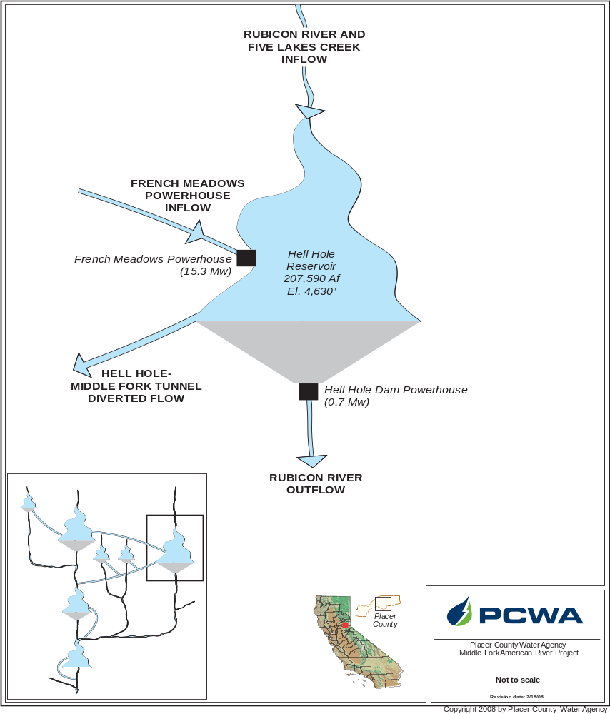

Hell Hole Reservoir Water Budget.
Month | Exceedances
Month | 10 % | 20% | 50% | 80% | 90%
Rubicon River and Five Lakes Creek Inflow
Oct | 21 | 8 | 2 | 1 | 0
Nov | 109 | 22 | 8 | 7 | 0
Dec | 166 | 60 | 21 | 12 | 0
Jan | 293 | 102 | 30 | 18 | 0
Feb | 325 | 166 | 56 | 42 | 0
Mar | 494 | 265 | 168 | 125 | 0
Apr | 769 | 458 | 289 | 202 | 0
May | 1199 | 697 | 311 | 189 | 0
Jun | 856 | 214 | 58 | 32 | 0
Jul | 111 | 32 | 9 | 2 | 0
Aug | 36 | 16 | 5 | 3 | 0
Sep | 20 | 8 | 4 | 2 | 0
French Meadows Powerhouse Inflow
Oct | 353 | 334 | 237 | 0 | 0
Nov | 343 | 327 | 0 | 0 | 0
Dec | 352 | 241 | 0 | 0 | 0
Jan | 334 | 239 | 0 | 0 | 0
Feb | 352 | 335 | 58 | 0 | 0
Mar | 362 | 345 | 92 | 0 | 0
Apr | 360 | 326 | 0 | 0 | 0
May | 359 | 326 | 0 | 0 | 0
Jun | 365 | 325 | 197 | 0 | 0
Jul | 342 | 325 | 262 | 146 | 0
Aug | 341 | 326 | 269 | 173 | 0
Sep | 341 | 322 | 224 | 0 | 0
Hell Hole Reservoir
Hell Hole Reservoir Water Budget (continued).
Month | Exceedances
Month | 10 % |  | 20% |  | 50% |  | 80% |  | 90%
Rubicon River Outflow
Oct |  | 43 |  | 29 |  | 22 |  | 10 |  | 8
Nov |  | 24 |  | 23 |  | 22 |  | 14 |  | 8
Dec |  | 23 |  | 22 |  | 15 |  | 12 |  | 8
Jan |  | 26 |  | 17 |  | 13 |  | 12 |  | 11
Feb |  | 25 |  | 20 |  | 14 |  | 12 |  | 11
Mar |  | 24 |  | 21 |  | 15 |  | 12 |  | 11
Apr |  | 25 |  | 21 |  | 15 |  | 13 |  | 12
May |  | 38 |  | 24 |  | 21 |  | 14 |  | 12
Jun |  | 138 |  | 24 |  | 22 |  | 19 |  | 12
Jul |  | 23 |  | 23 |  | 22 |  | 17 |  | 11
Aug |  | 23 |  | 23 |  | 21 |  | 11 |  | 9
Sep |  | 30 |  | 23 |  | 22 |  | 11 |  | 9
Hell Hole - Middle Fork Tunnel Diverted Flow
Oct |  | 806 |  | 583 |  | 73 |  | 0 |  | 0
Nov |  | 688 |  | 584 |  | 384 |  | 6 |  | 0
Dec |  | 817 |  | 629 |  | 241 |  | 0 |  | 0
Jan |  | 776 |  | 473 |  | 159 |  | 0 |  | 0
Feb |  | 826 |  | 734 |  | 313 |  | 0 |  | 0
Mar |  | 898 |  | 796 |  | 339 |  | -13 |  | -24
Apr |  | 887 |  | 771 |  | 219 |  | -17 |  | -34
May |  | 914 |  | 852 |  | 335 |  | -3 |  | -10
Jun |  | 917 |  | 861 |  | 555 |  | 211 |  | 0
Jul |  | 896 |  | 845 |  | 570 |  | 308 |  | 26
Aug |  | 911 |  | 861 |  | 617 |  | 368 |  | 169
Sep |  | 883 |  | 711 |  | 487 |  | 139 |  | 0
Percent Diverted
Oct |  | 668 |  | 253 |  | 55 |  | 0 |  | 0
Nov |  | 3899 |  | 1397 |  | 173 |  | 4 |  | 0
Dec |  | 1724 |  | 952 |  | 132 |  | 0 |  | 0
Jan |  | 766 |  | 309 |  | 106 |  | 0 |  | 0
Feb |  | 269 |  | 190 |  | 95 |  | 0 |  | 0
Mar |  | 177 |  | 146 |  | 62 |  | -6 |  | -9
Apr |  | 134 |  | 100 |  | 36 |  | -4 |  | -8
May |  | 107 |  | 77 |  | 35 |  | -1 |  | -3
Jun |  | 337 |  | 191 |  | 101 |  | 34 |  | 0
Jul |  | 392 |  | 278 |  | 183 |  | 106 |  | 33
Aug |  | 419 |  | 312 |  | 231 |  | 153 |  | 113
Sep |  | 4477 |  | 438 |  | 216 |  | 88 |  | 0

North Fork Long Canyon
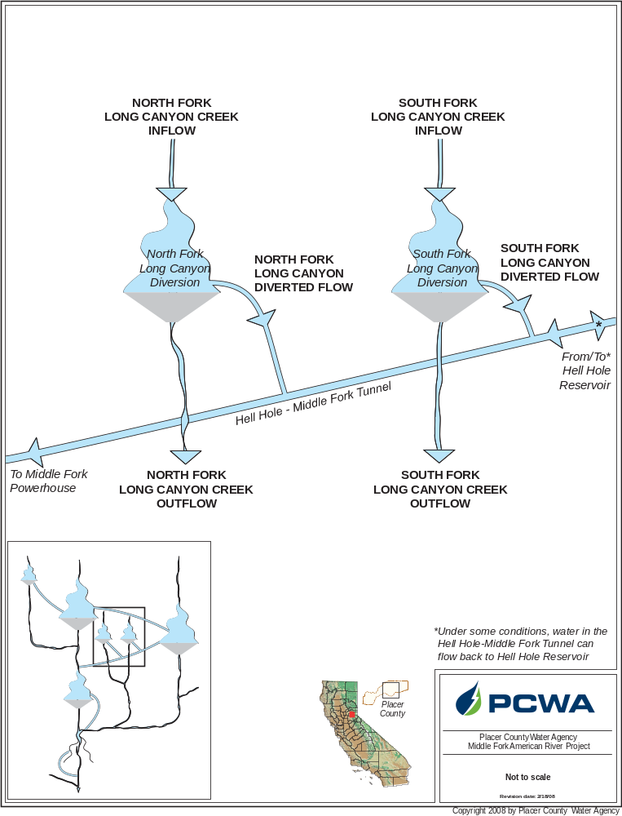

North Fork Long Canyon Diversion Water Budget.
Month | Exceedances
Month | 10 % | 20% | 50% | 80% | 90%
North Fork Long Canyon Creek Inflow
Oct | 1 | 1 | 0 | 0 | 0
Nov | 7 | 5 | 1 | 0 | 0
Dec | 20 | 8 | 3 | 1 | 1
Jan | 32 | 19 | 5 | 1 | 1
Feb | 36 | 22 | 10 | 4 | 2
Mar | 44 | 30 | 17 | 8 | 6
Apr | 40 | 32 | 20 | 9 | 6
May | 44 | 34 | 12 | 4 | 3
Jun | 14 | 8 | 3 | 1 | 1
Jul | 3 | 2 | 1 | 0 | 0
Aug | 1 | 1 | 0 | 0 | 0
Sep | 0 | 0 | 0 | 0 | 0
North Fork Long Canyon Creek Outflow
Oct | 1 | 1 | 0 | 0 | 0
Nov | 6 | 3 | 1 | 0 | 0
Dec | 11 | 6 | 2 | 1 | 1
Jan | 15 | 8 | 3 | 1 | 1
Feb | 16 | 6 | 3 | 2 | 2
Mar | 23 | 10 | 4 | 3 | 2
Apr | 14 | 6 | 3 | 2 | 2
May | 21 | 5 | 3 | 2 | 2
Jun | 7 | 5 | 3 | 1 | 1
Jul | 3 | 2 | 1 | 0 | 0
Aug | 1 | 1 | 0 | 0 | 0
Sep | 0 | 0 | 0 | 0 | 0
North Fork Long Canyon
North Fork Long Canyon Diversion Water Budget (continued).
Month | Exceedances
Month | 10 % | 20% | 50% | 80% | 90%
North Fork Long Canyon Diverted Flow
Oct | 0 | 0 | 0 | 0 | 0
Nov | 0 | 0 | 0 | 0 | 0
Dec | 4 | 0 | 0 | 0 | 0
Jan | 18 | 10 | 0 | 0 | 0
Feb | 21 | 13 | 3 | 0 | 0
Mar | 31 | 22 | 9 | 0 | 0
Apr | 33 | 26 | 12 | 2 | 0
May | 33 | 22 | 4 | 0 | 0
Jun | 6 | 1 | 0 | 0 | 0
Jul | 0 | 0 | 0 | 0 | 0
Aug | 0 | 0 | 0 | 0 | 0
Sep | 0 | 0 | 0 | 0 | 0
Percent Diverted
Oct | 0 | 0 | 0 | 0 | 0
Nov | 6 | 0 | 0 | 0 | 0
Dec | 51 | 11 | 0 | 0 | 0
Jan | 84 | 71 | 0 | 0 | 0
Feb | 87 | 81 | 40 | 0 | 0
Mar | 90 | 86 | 72 | 0 | 0
Apr | 92 | 89 | 77 | 21 | 0
May | 93 | 88 | 54 | 0 | 0
Jun | 68 | 14 | 0 | 0 | 0
Jul | 0 | 0 | 0 | 0 | 0
Aug | 0 | 0 | 0 | 0 | 0
Sep | 0 | 0 | 0 | 0 | 0

South Fork Long Canyon

South Fork Long Canyon Diversion Water Budget.
Month | Exceedances
Month | 10 % | 20% | 50% | 80% | 90%
South Fork Long Canyon Creek Inflow
Oct | 2 | 1 | 1 | 0 | 0
Nov | 16 | 8 | 2 | 1 | 1
Dec | 37 | 14 | 5 | 2 | 1
Jan | 56 | 32 | 9 | 2 | 2
Feb | 67 | 41 | 19 | 6 | 4
Mar | 79 | 56 | 29 | 14 | 11
Apr | 73 | 59 | 36 | 18 | 14
May | 81 | 61 | 31 | 11 | 7
Jun | 34 | 20 | 6 | 3 | 2
Jul | 6 | 3 | 1 | 1 | 1
Aug | 1 | 1 | 1 | 0 | 0
Sep | 1 | 1 | 1 | 0 | 0
South Fork Long Canyon Creek Outflow
Oct | 2 | 1 | 1 | 0 | 0
Nov | 9 | 5 | 2 | 1 | 1
Dec | 17 | 8 | 4 | 2 | 1
Jan | 21 | 8 | 5 | 2 | 2
Feb | 23 | 8 | 6 | 4 | 3
Mar | 41 | 14 | 6 | 5 | 4
Apr | 20 | 7 | 6 | 5 | 4
May | 35 | 7 | 6 | 5 | 3
Jun | 9 | 6 | 5 | 2 | 2
Jul | 5 | 3 | 1 | 1 | 1
Aug | 1 | 1 | 1 | 0 | 0
Sep | 1 | 1 | 1 | 0 | 0
South Fork Long Canyon
South Fork Long Canyon Diversion Water Budget (continued).
Month | Exceedances
Month | 10 % | 20% | 50% | 80% | 90%
South Fork Long Canyon Diverted Flow
Oct | 0 | 0 | 0 | 0 | 0
Nov | 1 | 0 | 0 | 0 | 0
Dec | 10 | 2 | 0 | 0 | 0
Jan | 34 | 20 | 0 | 0 | 0
Feb | 38 | 24 | 5 | 0 | 0
Mar | 61 | 40 | 15 | 1 | 0
Apr | 63 | 49 | 24 | 5 | 0
May | 60 | 50 | 15 | 2 | 0
Jun | 24 | 11 | 0 | 0 | 0
Jul | 0 | 0 | 0 | 0 | 0
Aug | 0 | 0 | 0 | 0 | 0
Sep | 0 | 0 | 0 | 0 | 0
Percent Diverted
Oct | 0 | 0 | 0 | 0 | 0
Nov | 21 | 0 | 0 | 0 | 0
Dec | 58 | 27 | 0 | 0 | 0
Jan | 86 | 76 | 0 | 0 | 0
Feb | 88 | 81 | 51 | 0 | 0
Mar | 91 | 86 | 67 | 10 | 0
Apr | 93 | 90 | 81 | 50 | 0
May | 92 | 89 | 74 | 22 | 0
Jun | 80 | 67 | 0 | 0 | 0
Jul | 0 | 0 | 0 | 0 | 0
Aug | 0 | 0 | 0 | 0 | 0
Sep | 0 | 0 | 0 | 0 | 0

Duncan Creek
Duncan Creek Diversion Water Budget.
Month | Exceedances
 | 10 % | 20 % | 50 % | 80 % | 90 %
Duncan Creek Inflow
Oct | 4 | 2 | 1 | 1 | 0
Nov | 29 | 13 | 3 | 1 | 1
Dec | 54 | 23 | 8 | 3 | 2
Jan | 82 | 42 | 13 | 4 | 3
Feb | 73 | 46 | 23 | 7 | 5
Mar | 112 | 72 | 37 | 21 | 15
Apr | 147 | 117 | 65 | 38 | 26
May | 234 | 188 | 93 | 36 | 20
Jun | 201 | 114 | 18 | 5 | 3
Jul | 20 | 9 | 3 | 1 | 1
Aug | 3 | 2 | 1 | 1 | 0
Sep | 2 | 1 | 1 | 0 | 0
Duncan Creek Outflow
Oct | 3 | 2 | 1 | 1 | 0
Nov | 12 | 7 | 3 | 1 | 1
Dec | 15 | 13 | 7 | 3 | 2
Jan | 20 | 15 | 10 | 4 | 3
Feb | 21 | 15 | 11 | 6 | 5
Mar | 21 | 17 | 13 | 10 | 9
Apr | 19 | 16 | 12 | 9 | 7
May | 42 | 18 | 11 | 8 | 5
Jun | 16 | 12 | 9 | 4 | 3
Jul | 10 | 7 | 3 | 1 | 1
Aug | 3 | 2 | 1 | 0 | 0
Sep | 2 | 1 | 1 | 0 | 0
Duncan Creek
Duncan Creek Diversion Water Budget (continued).
Month | Exceedances
 | 10 | 20 | 50 | 80 | 90
Duncan Creek - Middle Fork Tunnel Diverted Flow
Oct | 0 | 0 | 0 | 0 | 0
Nov | 20 | 4 | 0 | 0 | 0
Dec | 40 | 11 | 0 | 0 | 0
Jan | 51 | 24 | 2 | 0 | 0
Feb | 50 | 31 | 9 | 0 | 0
Mar | 86 | 55 | 24 | 8 | 3
Apr | 128 | 100 | 52 | 24 | 15
May | 193 | 151 | 80 | 26 | 12
Jun | 157 | 90 | 8 | 0 | 0
Jul | 12 | 1 | 0 | 0 | 0
Aug | 0 | 0 | 0 | 0 | 0
Sep | 0 | 0 | 0 | 0 | 0
Percent Diverted
Oct | 13 | 3 | 0 | 0 | 0
Nov | 71 | 42 | 4 | 0 | 0
Dec | 73 | 55 | 7 | 0 | 0
Jan | 76 | 65 | 21 | 0 | 0
Feb | 78 | 71 | 41 | 0 | 0
Mar | 84 | 78 | 62 | 37 | 22
Apr | 91 | 89 | 82 | 67 | 57
May | 94 | 92 | 85 | 65 | 49
Jun | 91 | 87 | 46 | 0 | 0
Jul | 62 | 13 | 0 | 0 | 0
Aug | 17 | 8 | 0 | 0 | 0
Sep | 13 | 6 | 0 | 0 | 0

